[#MakeoverMondayCoursera](https://twitter.com/hashtag/MakeoverMondayCoursera?src=hashtag_click)

Essential Design Principles for Tableau. Capstone project

Sales for Sylvia

Amazing

<https://twitter.com/yukochy/status/1340036750312398848>

Done!!! Please check out my beauty…:

<https://www.coursera.org/learn/dataviz-design/peer/fctld/designing-a-visualization-for-your-manager/review/gIleukF0Eeu4jBLNR3vU1w>

Thanks.

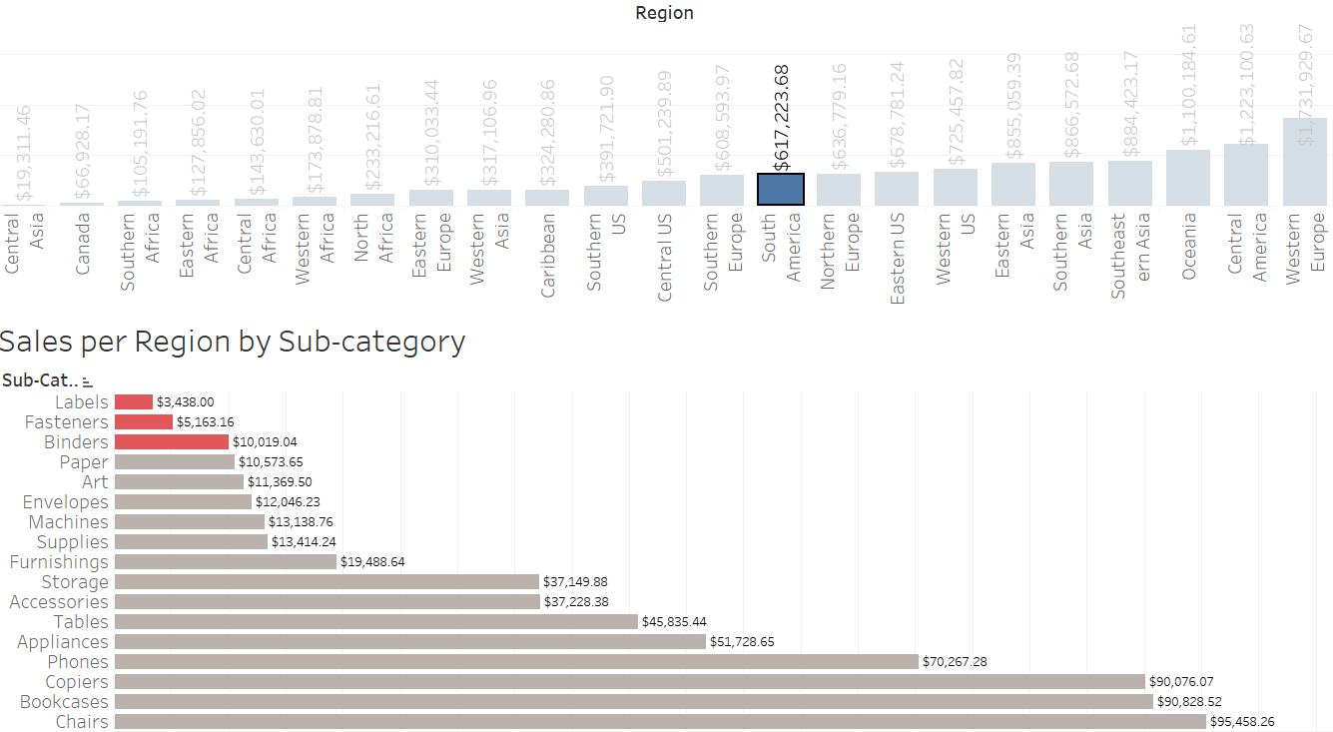

* How does your visualization leverage at least one “pop-out effect” or “pre-attentive attribute?” Which one(s) was (were) chosen and why?

**The Top3 lowest sales are highlighted in red color, other bars are in light gray color.**

* How does your visualization utilize at least one Gestalt principle? Which principle(s) is (are) being reflected, and how?

**It seems there you can find a couple Gestalt Principles such like Similarity (The best and the worst sale sub categories a grouped and highlighted), Closer (the explanatory analysis is finished, all information is there)**

* How does your design reflect an understanding of cognitive load and clutter?

**Tried to de-clutter as much as possible: values on the bar instead of axis tickets, minimum info and Titles, only pure information and nothing more. Sorting and red highlighting strictly calls system1 of cognitive reaction. If you need more info (system 2), go ahead and try filters by region.**

* Is your visualization static or interactive? Why did you choose that format?

**Its interactive and I dicedet to use filters. I see no another way to show three categories in one sheet: region, sub categories and sales.**

* What need does this visualization address that words or numbers alone cannot fill?

**It’s that case, when a couple bars can do all job instead of thousand words. And also I can easily concentrate attention on most important things (poor sales on some sub categoreies)**